**PL ASSIGNEMENT 9**

**NAME : Aditya Zade**

**PRN : 2018BTECS00111**

**Screen shot of code :**

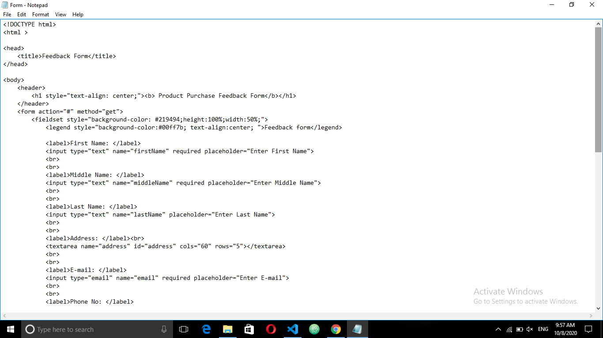

**Screen shot of webpage:**

